

Semester One Examination, 2018

Question/Answer booklet

MATHEMATICS

SOLUTIONS
METHODS
UNIT 3

Section Two:

Calculator-assumed

Student number: In figures

In words

Your name

Time allowed for this section
Reading time before commencing work: ten minutes
Working time: one hundred minutes

Materials required/recommended for this section
To be provided by the supervisor
This Question/Answer booklet
Formula sheet (retained from Section One)

To be provided by the candidate
Standard items: pens (blue/black preferred), pencils (including coloured), sharpener,
correction fluid/tape, eraser, ruler, highlighters

Special items: drawing instruments, templates, notes on two unfolded sheets of A4 paper, and up to three calculators approved for use in this examination

Important note to candidates
No other items may be taken into the examination room. It is your responsibility to ensure that you do not have any unauthorised material. If you have any unauthorised material with you, hand it to the supervisor before reading any further.

Structure of this paper

Section | Number of questions available | Number of questions to be answered | Working  time (minutes) | Marks available | Percentage of examination
Section One:  Calculator-free | 8 | 8 | 50 | 52 | 35
Section Two:  Calculator-assumed | 13 | 13 | 100 | 98 | 65
 |  |  |  | Total | 100

Instructions to candidates

1. The rules for the conduct of examinations are detailed in the school handbook. Sitting this examination implies that you agree to abide by these rules.

2. Write your answers in this Question/Answer booklet.

3. You must be careful to confine your response to the specific question asked and to follow any instructions that are specified to a particular question.

4. Supplementary pages for the use of planning/continuing your answer to a question
have been provided at the end of this Question/Answer booklet. If you use these pages to continue an answer, indicate at the original answer where the answer is continued, i.e. give the page number.

5. Show all your working clearly. Your working should be in sufficient detail to allow your answers to be checked readily and for marks to be awarded for reasoning. Incorrect answers given without supporting reasoning cannot be allocated any marks. For any question or part question worth more than two marks, valid working or justification is required to receive full marks. If you repeat any question, ensure that you cancel the answer you do not wish to have marked.

6. It is recommended that you do not use pencil, except in diagrams.

7. The Formula sheet is not to be handed in with your Question/Answer booklet.

Section Two: Calculator-assumed 65% (98 Marks)
This section has thirteen (13) questions. Answer all questions. Write your answers in the spaces provided.

Working time: 100 minutes.

Question 9 (6 marks)
$78\%$ of the fish in a large inland lake are known to be trout. Ten fish are caught at random from the lake every day.

(a) Describe, with parameters, a suitable probability distribution to model the number of trout in a day's catch. (2 marks)
Solution
Binomial, with $n=10$ and $p=0.78$

Specific behaviours
binomial
parameters

(b) Determine the probability that there are fewer trout than fish of other species in a day's catch. (2 marks)
Solution
$$P\left(X≤4\right)=0.0104$$

Specific behaviours
writes $P\left(X≤4\right)$ or $P\left(X<5\right)$
probability, to at least 3dp

(c) Calculate the probability that over two consecutive days, a total of exactly $19$ trout are caught. (2 marks)
Solution
$$X\sim B\left(20, 0.78\right)$$

$$P\left(X=19\right)=0.0392$$

Specific behaviours
defines new distribution
probability

Question 10 (8 marks)
The population of a city can be modelled by $P=P_{0}e^{kt}$, where $P$ is the number of people living in the city, in millions, $t$ years after the start of the year $2000$.

At the start of years $2009$ and $2013$ there were $1 945 000$ and $2 061 000$ people respectively living in the city.

(a) Determine the value of the constant $k$. (2 marks)
Solution
$$1.945=2.061e^{4k}$$

$$k=0.01448$$

Specific behaviours
equation
value of $k$ to at least 3sf

(b) Determine the value of the constant $P_{0}$. (2 marks)
Solution
$$1.945=P_{0}e^{0.01448\left(9\right)}$$

$$P_{0}=1.707$$

Specific behaviours
equation
value of $P_{0}$ (in millions)

(c) Use the model to determine during which year the population of the city will first exceed $2 500 000$. (2 marks)
Solution
$$2.5=1.783e^{0.01448t}$$

$$t=26.3⇒\text{during} 2026$$

Specific behaviours
value of $t$
correct year

(d) Determine the rate of change of the city's population at the start of $2013$. (2 marks)
Solution
$$\frac{dP}{dt}=0.01448×2 061 000 \\ =29 800 \text{people per year}$$

Specific behaviours
substitutes into rate of change
correct rate with units

Question 11 (6 marks)
The graph of $f(x)=\begin{matrix}6x+1 \\ \overline{ x+1 }\end{matrix}$ is shown below.

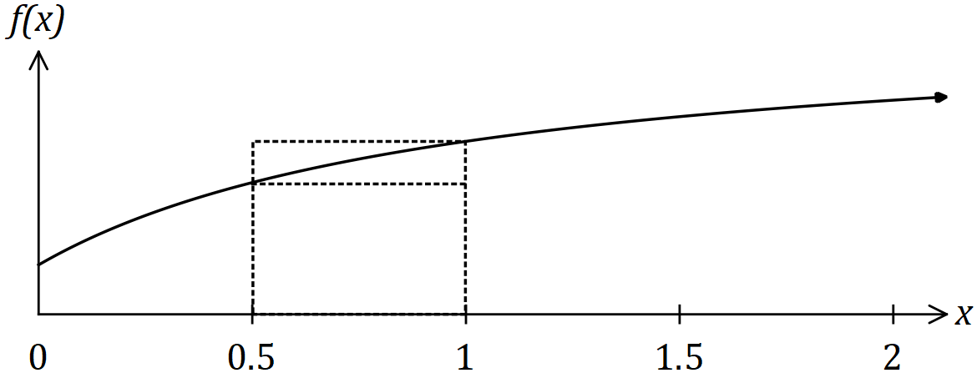

Two rectangles are also shown on the graph, with dotted lines, and they both have corners just touching the curve. The smaller is called the inscribed rectangle and the larger is called the circumscribed rectangle.
Solution (a)
See table
Specific behaviours
missing values

(a) Complete the missing values in the table below. (1 mark)

$$x$$ | $$0$$ | $$0.5$$ | $$1$$ | $$1.5$$ | $$2$$
$$f(x)$$ | $$1$$ | $$\frac{8}{3}$$ | $$\frac{7}{2}$$ | $$4$$ | $$\frac{13}{3}$$

(b) Complete the table of areas below and use the values to determine a lower and upper bound for $\int_{0}^{2}{\underset{ }{\overset{ }{f(x)}}}dx$. (4 marks)

$x$ interval | $0$ to $0.5$ | $0.5$ to $1$ | $1$ to $1.5$ | $1.5$ to $2$
Area of inscribed rectangle | $$\frac{1}{2}$$ | $$\frac{4}{3}$$ | $$\frac{7}{4}$$ | $$2$$
Area of circumscribed rectangle | $$\frac{4}{3}$$ | $$\frac{7}{4}$$ | $$2$$ | $$\frac{13}{6}$$
Solution
Lower bound: $L=\frac{1}{2}+\frac{4}{3}+\frac{7}{4}+2=\frac{67}{12}≈5.583$
Upper bound: $U=\frac{4}{3}+\frac{7}{4}+2+\frac{13}{6}=\frac{29}{4}=7.25$

Specific behaviours
inscribed areas
circumscribed areas
states lower bound
states upper bound

(c) Explain how the bounds you found in (b) would change if a larger number of smaller intervals were used. (1 mark)
Solution
The lower bound would increase and the upper bound decrease.

Specific behaviours
describes changes to both bounds

Question 12 (8 marks)
A fairground shooting range charges customers $\$6$ to take $9$ shots at a target. A prize of $\$20$ is awarded if a customer hits the target three times and a prize of $\$40$ is awarded if a customer hits the target more than three times. Otherwise no prize money is paid.

Assume that successive shots made by a customer are independent and hit the target with the probability $0.15$.

(a) Calculate the probability that the next customer to buy $9$ shots wins
Solution
$$X\sim B\left(9, 0.15\right)$$

$$P\left(X=3\right)=0.1069$$

Specific behaviours
defines distribution
calculates probability

(i) a prize of $\$20$. (2 marks)

(ii) a prize of $\$40$. (1 mark)
Solution
$$P\left(X≥4\right)=0.0339$$

Specific behaviours
calculates probability

(b) Calculate the expected profit made by the shooting range from the next $30$ customers who pay for $9$ shots at the target. (3 marks)
Solution
Let $Y$ be the profit per customer
$$P\left(Y=6\right)=0.8592 \\ P\left(Y=-14\right)=0.1069 \\ P\left(Y=-34\right)=0.0339$$

$$E\left(Y\right)=2.504$$

$$\text{Expected profit}=30×2.504=\$75.13$$

Specific behaviours
indicates probability distribution
calculates expected value for one customer
calculates expected value

(c) Determine the probability that more than $6$ out of the next $8$ customers will not win a prize. (2 marks)
Solution
$$X\sim B\left(8, 0.8592\right)$$

$$P\left(X≥7\right)=0.6862$$

Specific behaviours
defines distribution
calculates probability

Question 13 (8 marks)
Three functions are defined by $f\left(x\right)=9e^{-0.07x}, g\left(x\right)=3e^{0.09x}$ and $h\left(x\right)=3$.

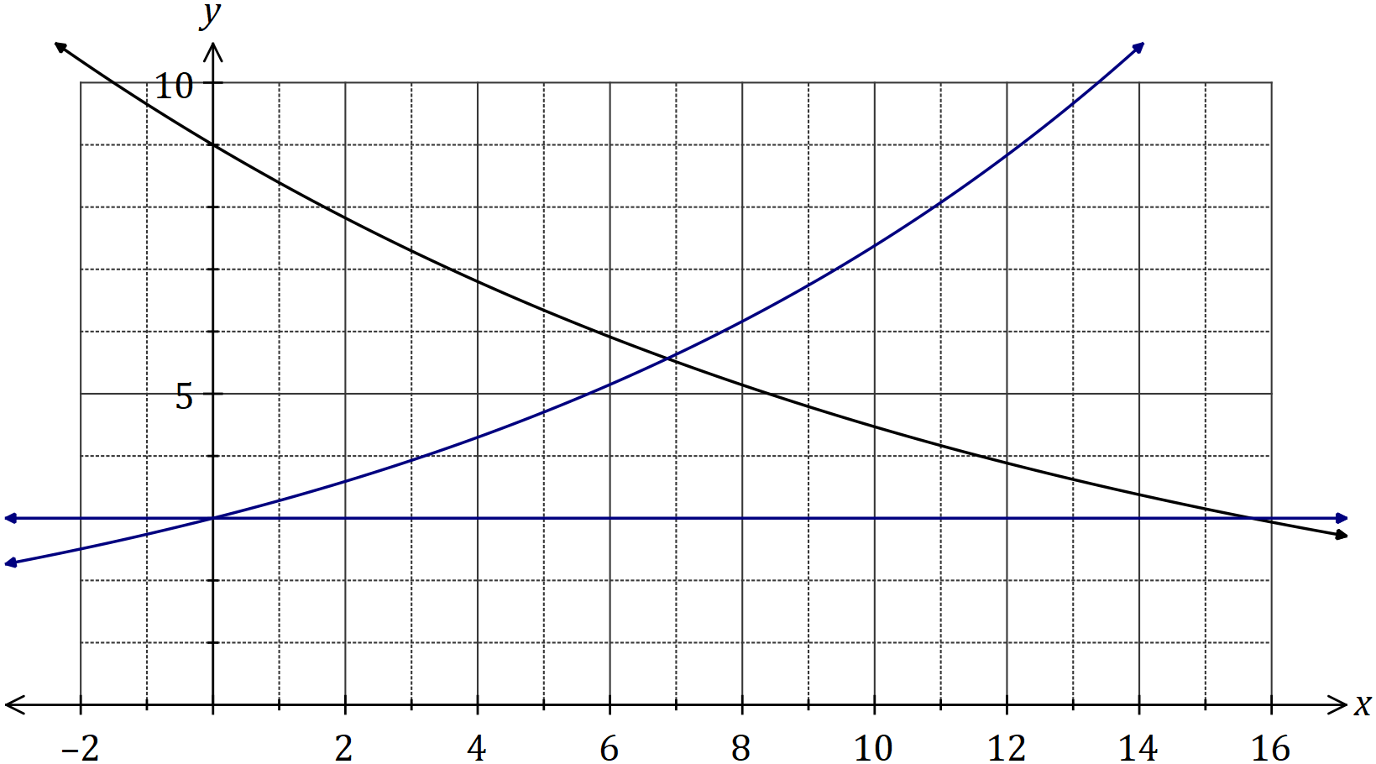
Solution
See graph
Specific behaviours
$y=h(x)$
$g(x)$ close to $(0, 3)$ and $(12, 9)$
$g(x)$ smooth curve

(a) One of the functions is shown on the graph above. Add the graphs of the other two functions. (3 marks)

(b) Working to three decimal places throughout, determine the area of the region enclosed by all three functions. (5 marks)
Solution
$$f\left(x\right)=g\left(x\right)\text{ when} x=6.866$$

$$\int_{0}^{6.866}{g\left(x\right)-h\left(x\right)}dx=7.905$$

$$g\left(x\right)=h\left(x\right)\text{ when} x=15.694$$

$$\int_{6.866}^{15.694}{f\left(x\right)-h\left(x\right)}dx=10.166$$

$$\text{Area}=7.905+10.166=18.071 \text{sq units}$$

Specific behaviours
writes first integral
evaluates first integral
writes second integral
evaluates second integral
total area
(Rounding instruction supplied for guidance only)

Question 14 (7 marks)
A fuel storage tank, initially containing $3 750$ L, is being filled at a rate given by

$$\begin{matrix}dV \\ \overline{dt}\end{matrix}=\frac{t^{2}(240-3t)}{500}, 0≤t≤80$$

where $V$ is the volume of fuel in the tank in litres and $t$ is the time in minutes since filling began. The tank will be completely full after $80$ minutes.

(a) Calculate the volume of fuel in the tank after half-an-hour. (3 marks)
Solution
$$ΔV=\int_{0}^{30}{V^{'}\left(t\right)}dt$$
$$=3105$$

$$V=3750+3105=6 855 \text{L}$$

Specific behaviours
indicates use of integral of rate of change
calculates increase
states volume

(b) Determine the time taken for the tank to fill to three-quarters of its maximum capacity.
(4 marks)
Solution
$$V=3750+\int_{0}^{80}{V^{'}\left(t\right)}dt \\ =3750+20480=24230$$

$$V\left(T\right)=\int_{0}^{T}{V^{'}\left(t\right)}dt=\frac{{4T}^{3}}{25}-\frac{{3T}^{4}}{2000}+3750$$

$$\frac{{4T}^{3}}{25}-\frac{{3T}^{4}}{2000}+3750=\frac{3×24230}{4}$$

$$T=58.4 \text{minutes}$$

Specific behaviours
calculates $V_{MAX}$
indicates $V(T)$
indicates equation
solves for time

Question 15 (8 marks)
The discrete random variable $X$ has a mean of $5.28$ and the following probability distribution.

$$x$$ | $$3$$ | $$4$$ | $$5$$ | $$6$$ | $$7$$
$$P(X=x)$$ | $$0.15$$ | $$a$$ | $$b$$ | $$0.2$$ | $$0.2$$

(a) Determine the values of the constants $a$ and $b$. (3 marks)
Solution
$$a+b+0.55=1$$

$$4a+5b+3.05=5.28$$

$$a=0.02, b=0.43$$

Specific behaviours
equation using sum of probabilities
equation using mean
values of $a$ and $b$

(b) Determine $P\left(X<4 | X<7\right)$. (2 marks)
Solution
$$P\left(X<4 | X<7\right)=\frac{0.15}{0.8}=0.1875=\frac{3}{16}$$

Specific behaviours
denominator
numerator and expresses as decimal or fraction

(c) Determine

(i) $\operatorname{Var}{(X)}$. (1 mark)
Solution
$$\operatorname{Var}\left(X\right)=1.5416 \text{(using CAS)}$$

Specific behaviours
correct variance

(ii) $E⁡(100-15X)$. (1 mark)
Solution
$$E\left(100-15X\right)=100-15×5.28=20.8$$

Specific behaviours
correct mean

(iii) $\operatorname{Var}{(12-5X)}$. (1 mark)
Solution
$$\operatorname{Var}\left(12-5X\right)={\left(-5\right)}^{2}×1.5416=38.54$$

Specific behaviours
correct variance

Question 16 (9 marks)
A particle starts from rest at $O$ and travels in a straight line.

Its velocity $v$ ms⁻¹, at time $t$ s, is given by $v=8t-t^{2}$ for $0≤t≤3$ and $v=135t^{-2}$ for $t>3$.

(a) Determine the initial acceleration of the particle. (2 marks)
Solution
$$a=\frac{dv}{dt}=8-2t⇒a\left(0\right)=8 {\text{ms}}^{-2}$$

Specific behaviours
differentiates velocity
acceleration

(b) Calculate the change in displacement of the particle during the first three seconds.
(2 marks)
Solution
$$x=\int_{0}^{3}{8t-t^{2}}dt=27 \text{m}$$

Specific behaviours
integrates velocity
change in displacement

(c) Determine, in terms of $t$, an expression for the displacement, $x$ m, of the particle from $O$ for $t>3$. (2 marks)
Solution
$$x=\int{\frac{135}{t^{2}}}dt=-\frac{135}{t}+c$$

$$x\left(3\right)=27=-\frac{135}{3}+c⇒c=72$$

$$x=-\frac{135}{t}+72$$

Specific behaviours
integrates velocity
evaluates $c$

(d) Determine the distance of the particle from $O$ when its acceleration is $-1.25$ ms⁻².
(3 marks)
Solution
$$a=-\frac{270}{t^{3}}$$

$$-\frac{270}{t^{3}}=-1.25⇒t=6$$

$$x\left(6\right)=49.5⇒\text{Distance from} O=49.5 \text{m}$$

Specific behaviours
acceleration for $t>3$
solves for time
calculates distance

Question 17 (7 marks)
A random sample of $n$ components are selected at random from a factory production line. The proportion of components that are defective is $p$ and the probability that a component is defective is independent of the condition of any other component.

The random variable $X$ is the number of faulty components in the sample. The mean and standard deviation of $X$ are $30.6$ and $5.1$ respectively.

(a) Determine the values of $n$ and $p$. (4 marks)
Solution
$$X\sim B(n, p)$$

$$np=30.6$$

$$np\left(1-p\right)={5.1}^{2}$$

$$n=204, p=0.15$$

Specific behaviours
indicates binomial distribution
equation using mean
equation using standard deviation
solves correctly for $n$ and $p$

(b) After changes are made to the manufacturing process, the proportion of defective components is now $3\%$. Determine the smallest sample size required to ensure that the probability that the sample contains at least one defective component is at least $0.95$.
(3 marks)
Solution
$$X\sim B\left(n, 0.03\right)$$
$$P\left(X≥1\right)≥0.95 \\ 1-P\left(X=0\right)≥0.95$$
$$P\left(X=0\right)<0.05 \\ {0.97}^{n}<0.05$$

$$n>98.4⇒n≥99$$

Specific behaviours
indicates required binomial probability
uses $P(X=0)$ to create inequality
solves and rounds to obtain $n$

Question 18 (11 marks)
The air pressure, $P(h)$ in kPa, experienced by a weather balloon varies with its height above sea level $h$ km and is given by

$$P\left(h\right)={101.5e}^{-0.135h}, 0≤h≤20 .$$

(a) Determine $\begin{matrix}dP \\ \overline{dh}\end{matrix}$ when the height of the balloon is $5.5$ km. (2 marks)
Solution
$$\frac{dP}{dh}=-0.135×101.5e^{-0.135\left(5.5\right)} \\ =-6.52 \text{kPa/km}$$

Specific behaviours
uses derivative
correct rate of change

(b) What is the meaning of your answer to (a). (1 mark)
Solution
The rate of change of pressure with respect to height when the height is $5.5$ km.

Specific behaviours
meaning (must include wrt $h$ and refer to height)

The height of the balloon above sea level varies with time $t$ minutes and is given by

$$h\left(t\right)=\frac{t^{2}(120-t)}{12800}, 0≤t≤80 .$$

(c) Determine the air pressure experienced by the balloon when $t=48$. (2 marks)

Solution
$$h\left(48\right)=12.96 \text{km}$$

$$P\left(12.96\right)=17.65 \text{kPa}$$

Specific behaviours
determines height
determines pressure

(d) Determine $\begin{matrix}dh \\ \overline{dt}\end{matrix}$ when the height of the balloon is $7.04$ km. (3 marks)
Solution
$$h(t)=7.04⇒t=32$$

$$\frac{dh}{dt}=\frac{240t-3t^{2}}{12800} \\ =\frac{240\left(32\right)-3{\left(32\right)}^{2}}{12800}=\frac{9}{25}=0.36 \text{km/m}$$

Specific behaviours
determines time
indicates derivative
determines rate of change

(e) Determine $\begin{matrix}dP \\ \overline{dt}\end{matrix}$ when the height of the balloon is $7.04$ km. (3 marks)
Solution
$$\frac{dP}{dh}=-0.135×101.5e^{-0.135\left(7.04\right)} \\ =-5.297$$

$$\frac{dP}{dt}=\frac{dP}{dh}×\frac{dh}{dt} \\ =-5.297×0.36 \\ =-1.91 \text{kPa/m}$$

Specific behaviours
rate of change of $P$ wrt $h$
indicates use of chain rule
correct rate of change

Question 19 (7 marks)
The hourly cost of fuel to run a train is proportional to the square of its speed and is $\$36$ per hour when the train moves at a speed of $16$ kmh⁻¹. Other costs amount to $\$144$ per hour, regardless of speed.

(a) Show that when the train moves at a steady speed of $x$ kmh⁻¹, where $x>0$, the total cost per kilometre, $C$, is given by (3 marks)
$$C=\frac{9x}{64}+\frac{144}{x}.$$
Solution
Fuel cost, $f$, is
$$f=kx^{2}⇒k=\frac{36}{{16}^{2}}=\frac{9}{64}$$
Total cost per hour, $t$, is
$$t=\frac{9x^{2}}{64}+144$$
Cost per km, $C$, is
$$C=\frac{t}{x}=\frac{9x}{64}+\frac{144}{x}$$

Specific behaviours
expression for hourly cost of fuel
expression for total cost per hour
indicates derivation of cost per km

(b) Use calculus to determine the minimum cost for the train to travel $240$ km, assuming that the train travels at a constant speed for the entire journey. (4 marks)
Solution
$$\frac{dC}{dx}=\frac{9x^{2}-9216}{64x^{2}}$$

$$\frac{dC}{dx}=0⇒x=32 (x>0)$$

$$C=\frac{9\left(32\right)}{64}+\frac{144}{32}=9$$

$$\text{Journey cost}=9×240=\$2 160$$

Specific behaviours
obtains first derivative
indicates critical point
indicates optimum cost per km
correct minimum cost

Question 20 (6 marks)
The discrete random variable $X$ is defined by

$$P\left(X=x\right)=\left\{\begin{matrix}\frac{2k}{e^{1-x}} & x=0, 1 \\ & \\ 0 & \text{elsewhere.}\end{matrix}\right.$$

(a) Show that $k=\begin{matrix}e \\ \overline{2+2e}\end{matrix}$. (3 marks)
Solution
$$\frac{2k}{e}+\frac{2k}{1}=1$$

$$k\left(\frac{2+2e}{e}\right)=1$$

$$k=\frac{e}{2+2e}$$

Specific behaviours
indicates $P(X=0)$ and $P(X=1)$
sums probabilities to 1
factors out $k$ and rearranges

(b) Determine, in simplest form, the exact mean and standard deviation of $X$. (3 marks)
Solution
NB Bernoulli distribution.

$$E\left(X\right)=2k=\frac{e}{1+e}$$

$$\operatorname{Var}\left(X\right)=\frac{2k}{e}×2k=\frac{2^{2}k^{2}}{e}$$

$$SD=\sqrt{\frac{2^{2}k^{2}}{e}}=\frac{2}{\sqrt{e}}\left(\frac{e}{2+2e}\right)=\frac{\sqrt{e}}{1+e}$$

Specific behaviours
simplified $E\left(X\right)$
correct expression for variance
simplified expression for standard deviation

Question 21 (7 marks)
The graph of $y=f(t)$ is shown below, where $f(t)=5\sin\left(\begin{matrix}πt \\ \overline{ 4 }\end{matrix}\right)$.

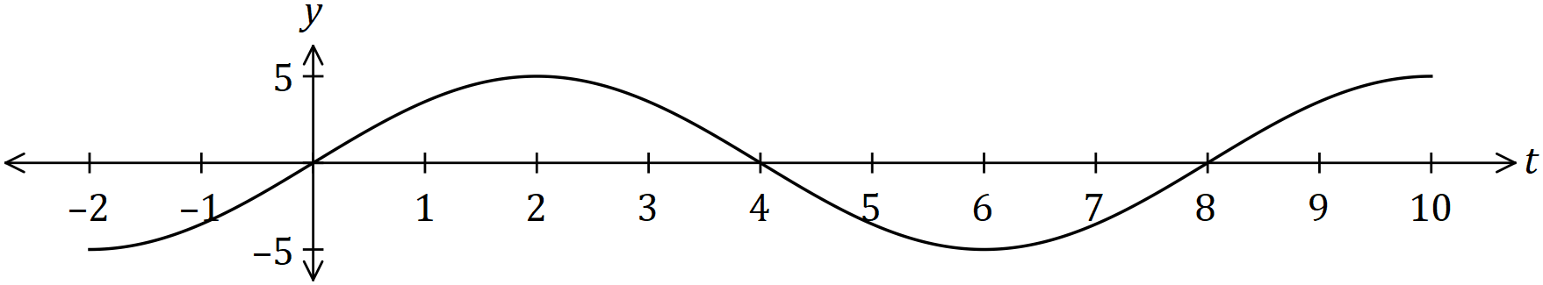

(a) Determine the exact area between the horizontal axis and the curve for $0≤t≤4$.
(2 marks)
Solution
$$\int_{0}^{4}{5\sin\left(\frac{πt}{4}\right)}=\frac{40}{π}$$

Specific behaviours
writes integral
evaluates

Another function, $F$, is defined as $F(x)=\int_{0}^{x}{\underset{ }{\overset{ }{f(t)}}}dt$ over the domain $0≤x≤16$.

(b) Determine the value(s) of $x$ for which $F(x)$ has a maximum and state the value of $F(x)$ at this location. (2 marks)
Solution
$$x=4, x=12, F\left(4\right)=F\left(12\right)=\frac{40}{π}$$

Specific behaviours
values of $x$
value of $F(x)$

(c) Sketch the graph of $y=F(x)$ on the axes below. (3 marks)

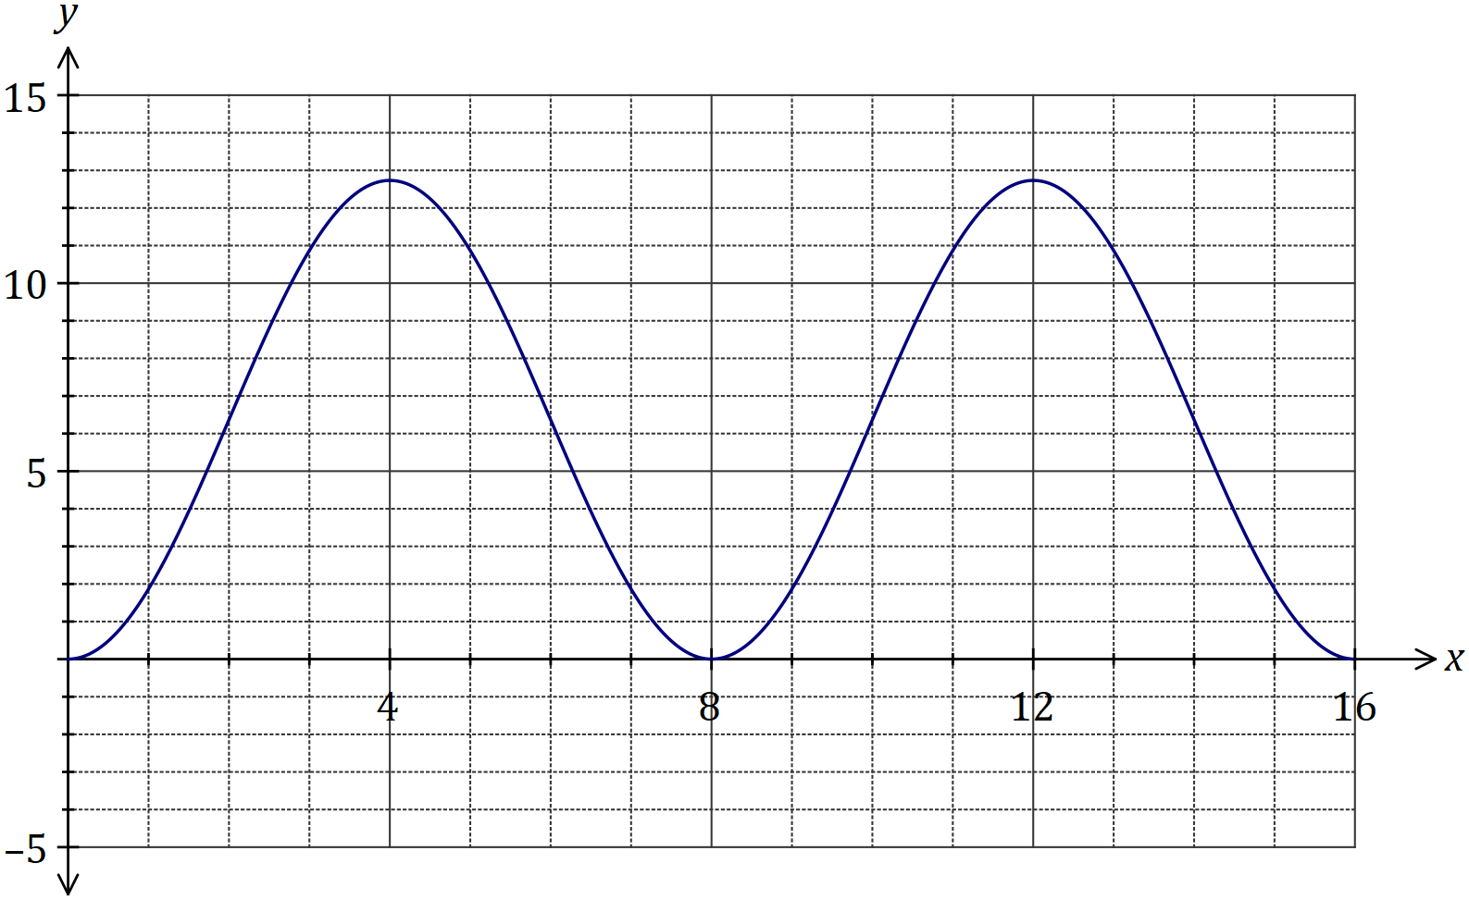
Solution
See graph
Specific behaviours
maxima
minima
smooth continuous curve

Supplementary page

Question number: _________

Supplementary page

Question number: _________

Supplementary page

Question number: _________

© 2018 WA Exam Papers. All Saints' College has a non-exclusive licence to copy and communicate this document for non-commercial, educational use within the school. No other copying, communication or use is permitted without the express written permission of WA Exam Papers. SN001-115-4.

